6.1 Rational Functions

Objectives: I can determine the domain, range, symmetry, end behavior, and intervals of increasing and decreasing of rational functions.

I can identify the transformation of a given function and sketch a graph

I can write a rational equation given a graph.

Rational Function:

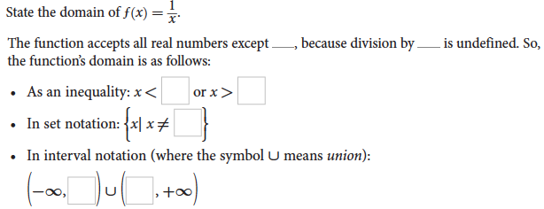

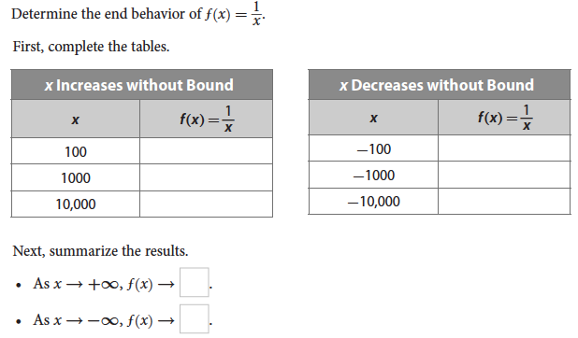

Limit notation:

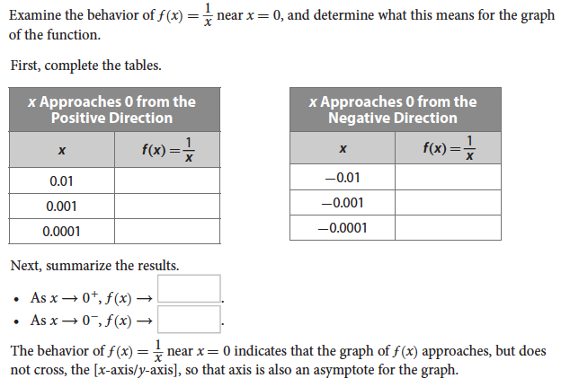

Limit Notation:

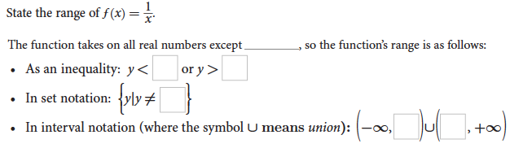

**Function Booklet**

Sketch a graph of the parent function in your function booklet and identify the domain, range, symmetry, increasing and decreasing intervals.

Look at the following graphs and the parent function from your function booklet and answer the questions below.

 

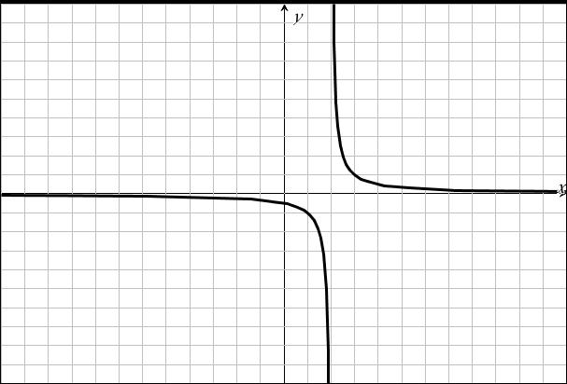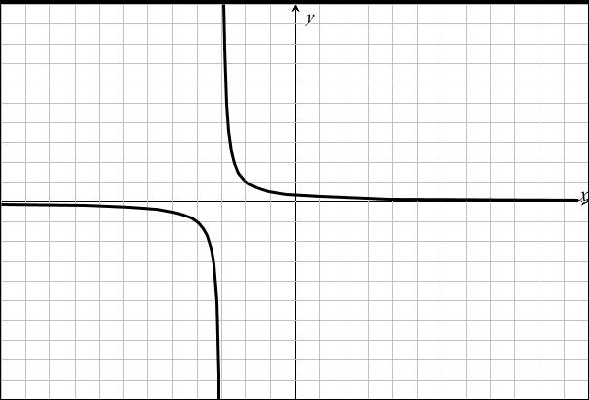

Based on the equations and corresponding graphs, what do you conclude about the transformations?

 

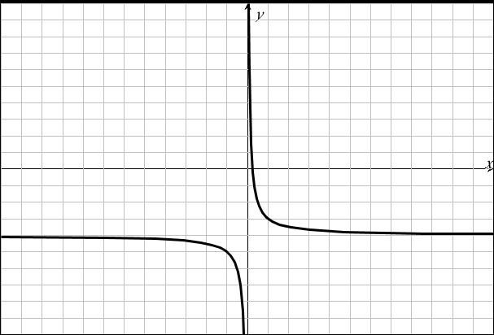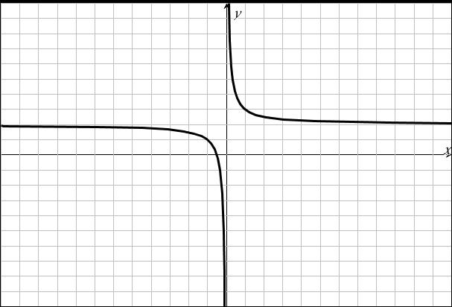

Based on the equations and corresponding graphs, what do you conclude about the transformations?

 

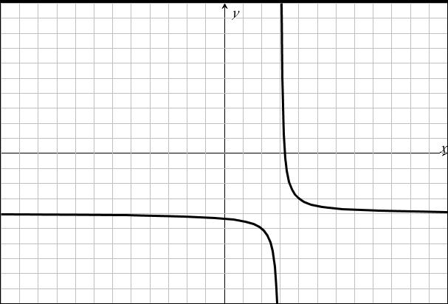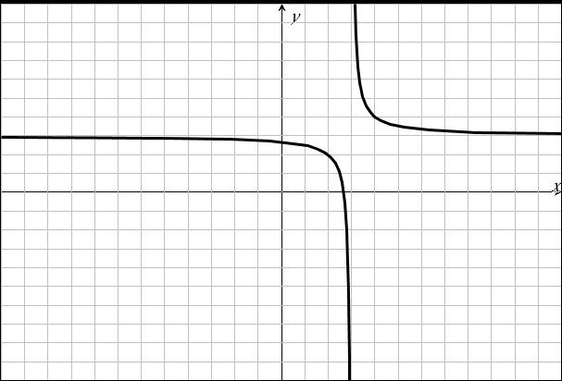

Based on the equations and corresponding graphs, what do you conclude about the transformations?

 

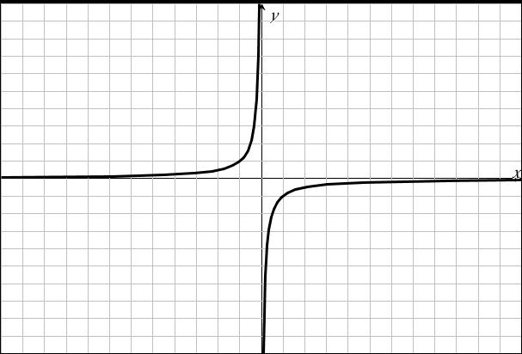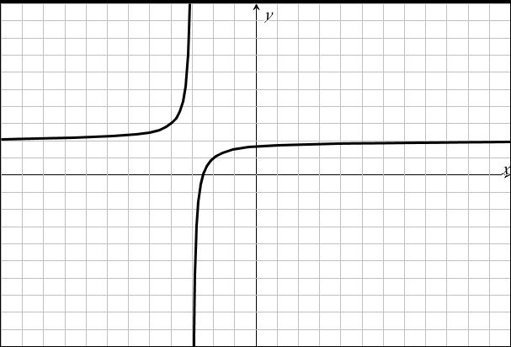

Based on the equations and corresponding graphs, what do you conclude about the transformations?

Discuss with a partner the patterns you notice above. Use those patterns to sketch a graph of the following.

 

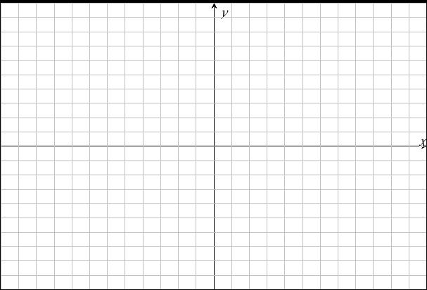

 



Based on the conclusions you made, work with a partner to write an equation based on the following graphs.

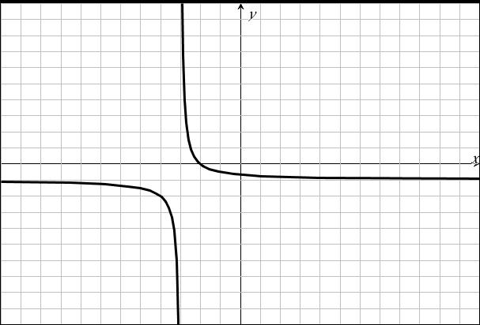

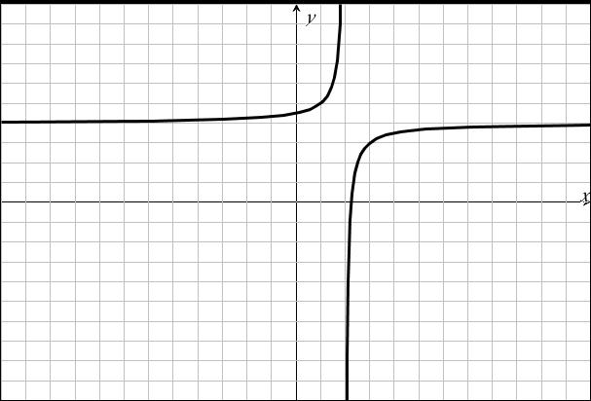

When given a rational function in the form of whereand, you can use long division to re-write the function in a form to identify the transformations.

Given , use long division to re-write the function and identify the transformations.

Given , use long division to re-write the function and identify the transformations. Then sketch a graph and state the domain, range, and intervals of increasing and decreasing.

Given use long division to re-write the function and identify the transformations. Then sketch a graph and state the domain, range, and intervals of increasing and decreasing.