1. Give the equation represented by the table. Equation: ____________________
x | y
0 | 0
1 | 1
4 | 2
9 | 3
16 | 4

2. Write the equation represented by the graph below. Equation:_____________________

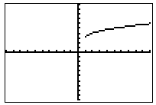

3. Graph the following equation; $y=-2\sqrt{x}-1$

