Warm-Up
Find the distance between:
1. (2, 3) and (-4, 5)

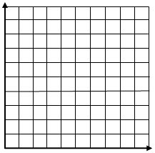
2.

