LINEAR/QUADRATIC/EXPONENTIAL TABLES

HOW TO RECOGNIZE THE TYPE OF GRAPH FROM A TABLE

To recognize if a function is linear, quadratic (a parabola), or exponential without an equation or graph, look at the differences of the y-values between successive integral x-values. If the difference is constant, the graph is linear. If the difference is not constant but the second set of differences are constant, the graph is quadratic. If the differences are not constant but form a common ratio, the graph is exponential. See the examples below for clarity.

Examples

Based on each table, identify the shape of the graph.

Example 1
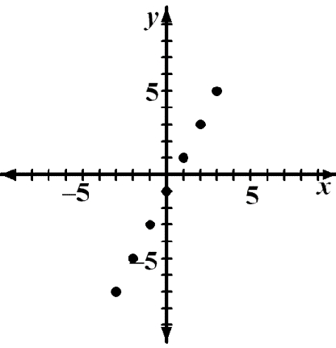
x | 3 | 2 | 1 | 0 | 1 | 2 | 3
y | 7 | 5 | 3 | 1 | 1 | 3 | 5
2 2 2 2 2 2

The difference in y-values is always two, a constant.

The graph is linear and is verified at right.

Example 2

x | 3 | 2 | 1 | 0 | 1 | 2 | 3
y | 9 | 4 | 1 | 0 | 1 | 4 | 9
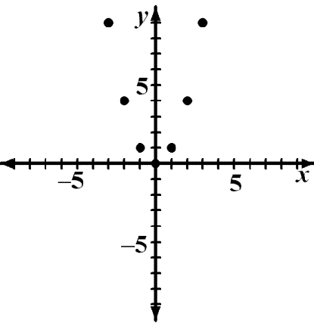
5 | 3 | 1 |  | 1 | 3 | 5
 | 2 | 2 | 2 | 2 |  | 2
The first difference in y-values is not constant but the

second difference is. The graph is quadratic and is verified at right.
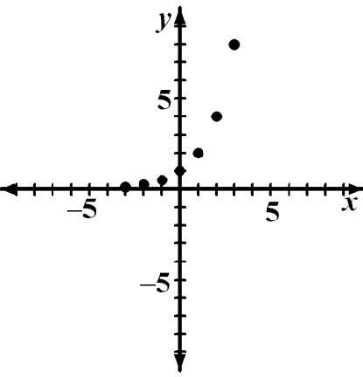
Example 3

 | x | 3 |  | 2 |  |  |  |  | 1 |  |  | 0 |  |  | 1 |  |  | 2 |  |  | 3
 | y | 1 |  | 1 |  |  |  |  | 1 |  |  | 1 |  |  | 2 |  |  | 4 |  |  | 8
 |  | 8 |  | 4 |  |  |  |  | 2
 |  | x2 |  | x2 |  |  |  |  |  | x2 |  |  |  | x2 |  |  | x2 |  |  | x2

The difference in y-values is not constant. The y-values
form a common ratio.

Problems
Based on the difference in y-values, identify the graph as linear, quadratic, exponential,
or neither.
1. |  |  |  |  |  |  |  |  |  |  |  | 2.
 | x | 3 |  | 2 | 1 | 0 | 1 | 2 | 3 |  |  | x | 3 | 2 |  |  | 1 |  | 0 |  |  | 1 |  |  | 2 |  |  | 3
 | y | 14 |  | 10 | 6 | 2 | –2 | –6 | –10 |  |  | y | 1 | 1 |  |  | 2 |  | 4 |  |  | 8 |  |  | 16 |  |  | 32
 |  |  |  |  |  |  |  |  |  |  |  |  | 2
3. |  |  |  |  |  |  |  |  |  |  |  | 4.
 | x | 3 |  | 2 | 1 | 0 | 1 | 2 | 3 |  |  | x | 3 |  | 2 |  | 1 |  |  | 0 |  |  | 1 |  |  | 2 |  |  | 3
 | y | 21 |  | 12 | 5 | 0 | –3 | –4 | –3 |  |  | y | –16 |  | –13 |  | –10 |  |  | –7 |  |  | –4 |  |  | –1 |  |  | 2

5.

x | 3 |  | 2 |  | 1 |  | 0 | 1 | 2 | 3
y | –14 |  | –9 |  | –4 |  | 1 | 6 | 11 | 16
7.
x | 3 |  | 2 |  | 1 |  | 0 | 1 | 2 | 3
y | 4 |  | 8 |  | 16 |  | 32 | 64 | 128 | 256
9.
x | 3 |  | 2 |  | 1 |  | 0 | 1 | 2 | 3
y | 30 |  | 20 |  | 12 |  | 6 | 2 | 0 | 0

6.

 | x | 3 |  | 2 |  | 1 |  | 0 | 1 | 2 | 3
 | y | –18 |  | –6 |  | –2 |  | 0 | 2 | 6 | 18
8.
 | x | 3 |  | 2 |  | 1 |  | 0 | 1 | 2 | 3
 |  | 1 |  | 1 |  | 1
 |  | 27 |  |  |  | 3 |  | 1 | 3 | 9 | 27
 | y |  |  | 9
10.
 | x | 3 |  | 2 |  | 1 |  | 0 | 1 | 2 | 3
 | y | 11 |  | 9 |  | 7 |  | 5 | 3 | 1 | –1

11. |  |  |  |  |  |  |  |  | 12.
 | x | 3 | 2 | 1 | 0 | 1 | 2 | 3 |  | x | 3 |  | 2 |  | 1 |  | 0 | 1 | 2 | 3
 | y | 1 | 1 | 1 | 3 | 9 | 27 | 81 |  | y | –27 |  | –9 |  | –3 |  | 0 | 3 | 9 | 27
 |  | 9 | 3
13. |  |  |  |  |  |  |  |  | 14.
 | x | 3 | 2 | 1 | 0 | 1 | 2 | 3 |  | x | 3 | 2 |  | 1 |  | 0 |  | 1 | 2 | 3
 | y | 0 | 5 | 8 | 9 | 8 | 5 | 0 |  | y | 3 | 0 |  | –1 |  | 0 |  | 3 | 8 | 15
15. |  |  |  |  |  |  |  |  | 16.
 | x | 3 | 2 | 1 | 0 | 1 | 2 | 3 |  | x | 3 | 2 |  | 1 |  | 0 |  | 1 | 2 | 3
 | y | 1 | 0 | –1 | –2 | –1 | 0 | 1 |  | y | 9 | 9 |  | 9 |  | 9 |  | 18 | 36 | 72
 |  |  |  |  |  |  |  |  |  |  | 8 | 4 |  | 2
Answers
1. | linear | 2. | exponential
3. | quadratic | 4. | linear
5. | linear | 6. | quadratic
7. | exponential | 8. | exponential
9. | quadratic | 10. | linear
11. | exponential | 12. | neither
13. | quadratic | 14. | quadratic
15. | neither | 15. | exponential

PDF to Word

