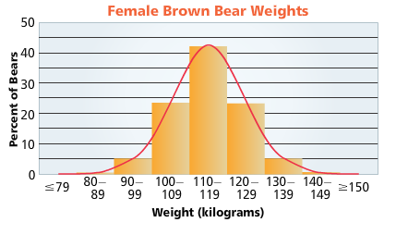
- The bar graph gives the weights of a population of female brown bears. The red curve shows how the weights are normally distributed about the mean, 115 kg. Approximately what percent of female brown bears weigh between 100 and 129 kg?

- Approximately what percent of female brown bears weigh less than 120 kg?

- The standard deviation in the weights of female brown bears is about 10 kg. Approximately what percent of female brown bears have weights that are within 1.5 standard deviations of the mean?

Discrete probability distribution has a finite number of possible events, or values (can you count it?)
Continuous probability distribution can be any value in an interval of real numbers
- Are the following examples discrete or continuous probability distributions?
- The fire department mandates that all fire fighters weigh between 150 and 200 lbs.
- Flipping a coin and counting the number of heads.
- What are some examples of discrete probability distributions?

- What are some examples of continuous probability distributions?

- Look at the graph from the brown bear problem (problem 1). What kind of probability distribution is it?

- What if we were to connect the bars and fit them under the curve, make a rough sketch of this, what kind of probability distribution would this be?

- This is called a normal distribution. What are some characteristics of this graph?

What facts are known about the amount of sleep we humans need?
While sleep undergoes a wide variety of modifications during the human life span (based primarily upon age), all aspects of sleep, at any given age, have a relatively normal, bell-shaped distribution.
A previous survey administered to high school students showed that the amount of sleep (in hours) in a 24-hour period is normally distributed with a mean of 7 hours and a standard deviation of 1.25.
- Sketch the normal distribution of the survey.

- What percent of the people in the survey slept between 5.75 to 8.25 hours?

- Between how many hours of sleep did 95% of the people in the survey receive?

- What percent of the people in the survey got less than 8.25 hours of sleep?

- What percent of the people in the survey slept more than 9.5 hours?

- Ask everyone at your table how many hours of sleep they got in the last 24 hours, to the nearest quarter hour. Record your data below.

- Place a dot on your normal distribution sketch representing the amount of sleep each person got.
  - Does your data look like a normal distribution?
  - Within how many standard deviations from the mean does your data lie?
  - Compare your results with other groups. Do any of them look normal?

- Combine all of the classroom data.
  - Do the people in our classroom follow a normal distribution? Show using the 68-95-99.7 rule.

