Review Unit 2 Name: _______________________________

Date: ______________ Period: ____________

1. Simplify the following:

A.  B. 

2. Simplify the following

3. Jane practices the piano for $5\frac{1}{2}$ hours each week. How many hours does she practice in a month?

4. Match the vocabulary words on the left with a definition on the right

______ 1. Point a. Two angles with measures that have a sum of 90

______ 2. Line b. Lines that intersect to form a right angle

______ 3. Acute Angle c. An angle greater than 90 and less than 180

______ 4. Parallel Lines d. An angle less than 90 degress

______ 5. Obtuse Angle e. A location that is represented as a dot

______ 6 Right Angle f. Two angles with measures that have a sum of 180

______ 7. Perpendicular Lines g. A line with a measure of 180 degrees

______ 8. Straight Angle h. An angle with a degree measure of 90

______ 9. Complimentary Angles i. Lines that don’t intersect and have the same slope

______ 10. Supplementary Angles j. Made up of points with arrows at each end

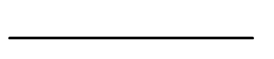

5. Find KL in the following figure

When JK= $\frac{1}{3}$ cm and JL= $\frac{5}{7}$ cm J K L

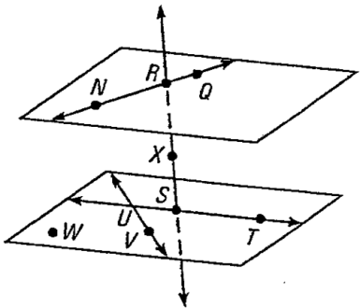**Use the diagram to name the figures.**

6. Name three collinear points.________________

7. Name three noncollinear points. _____________

8. Name four noncoplanar points. ______________

9. Name two intersecting lines. ______________

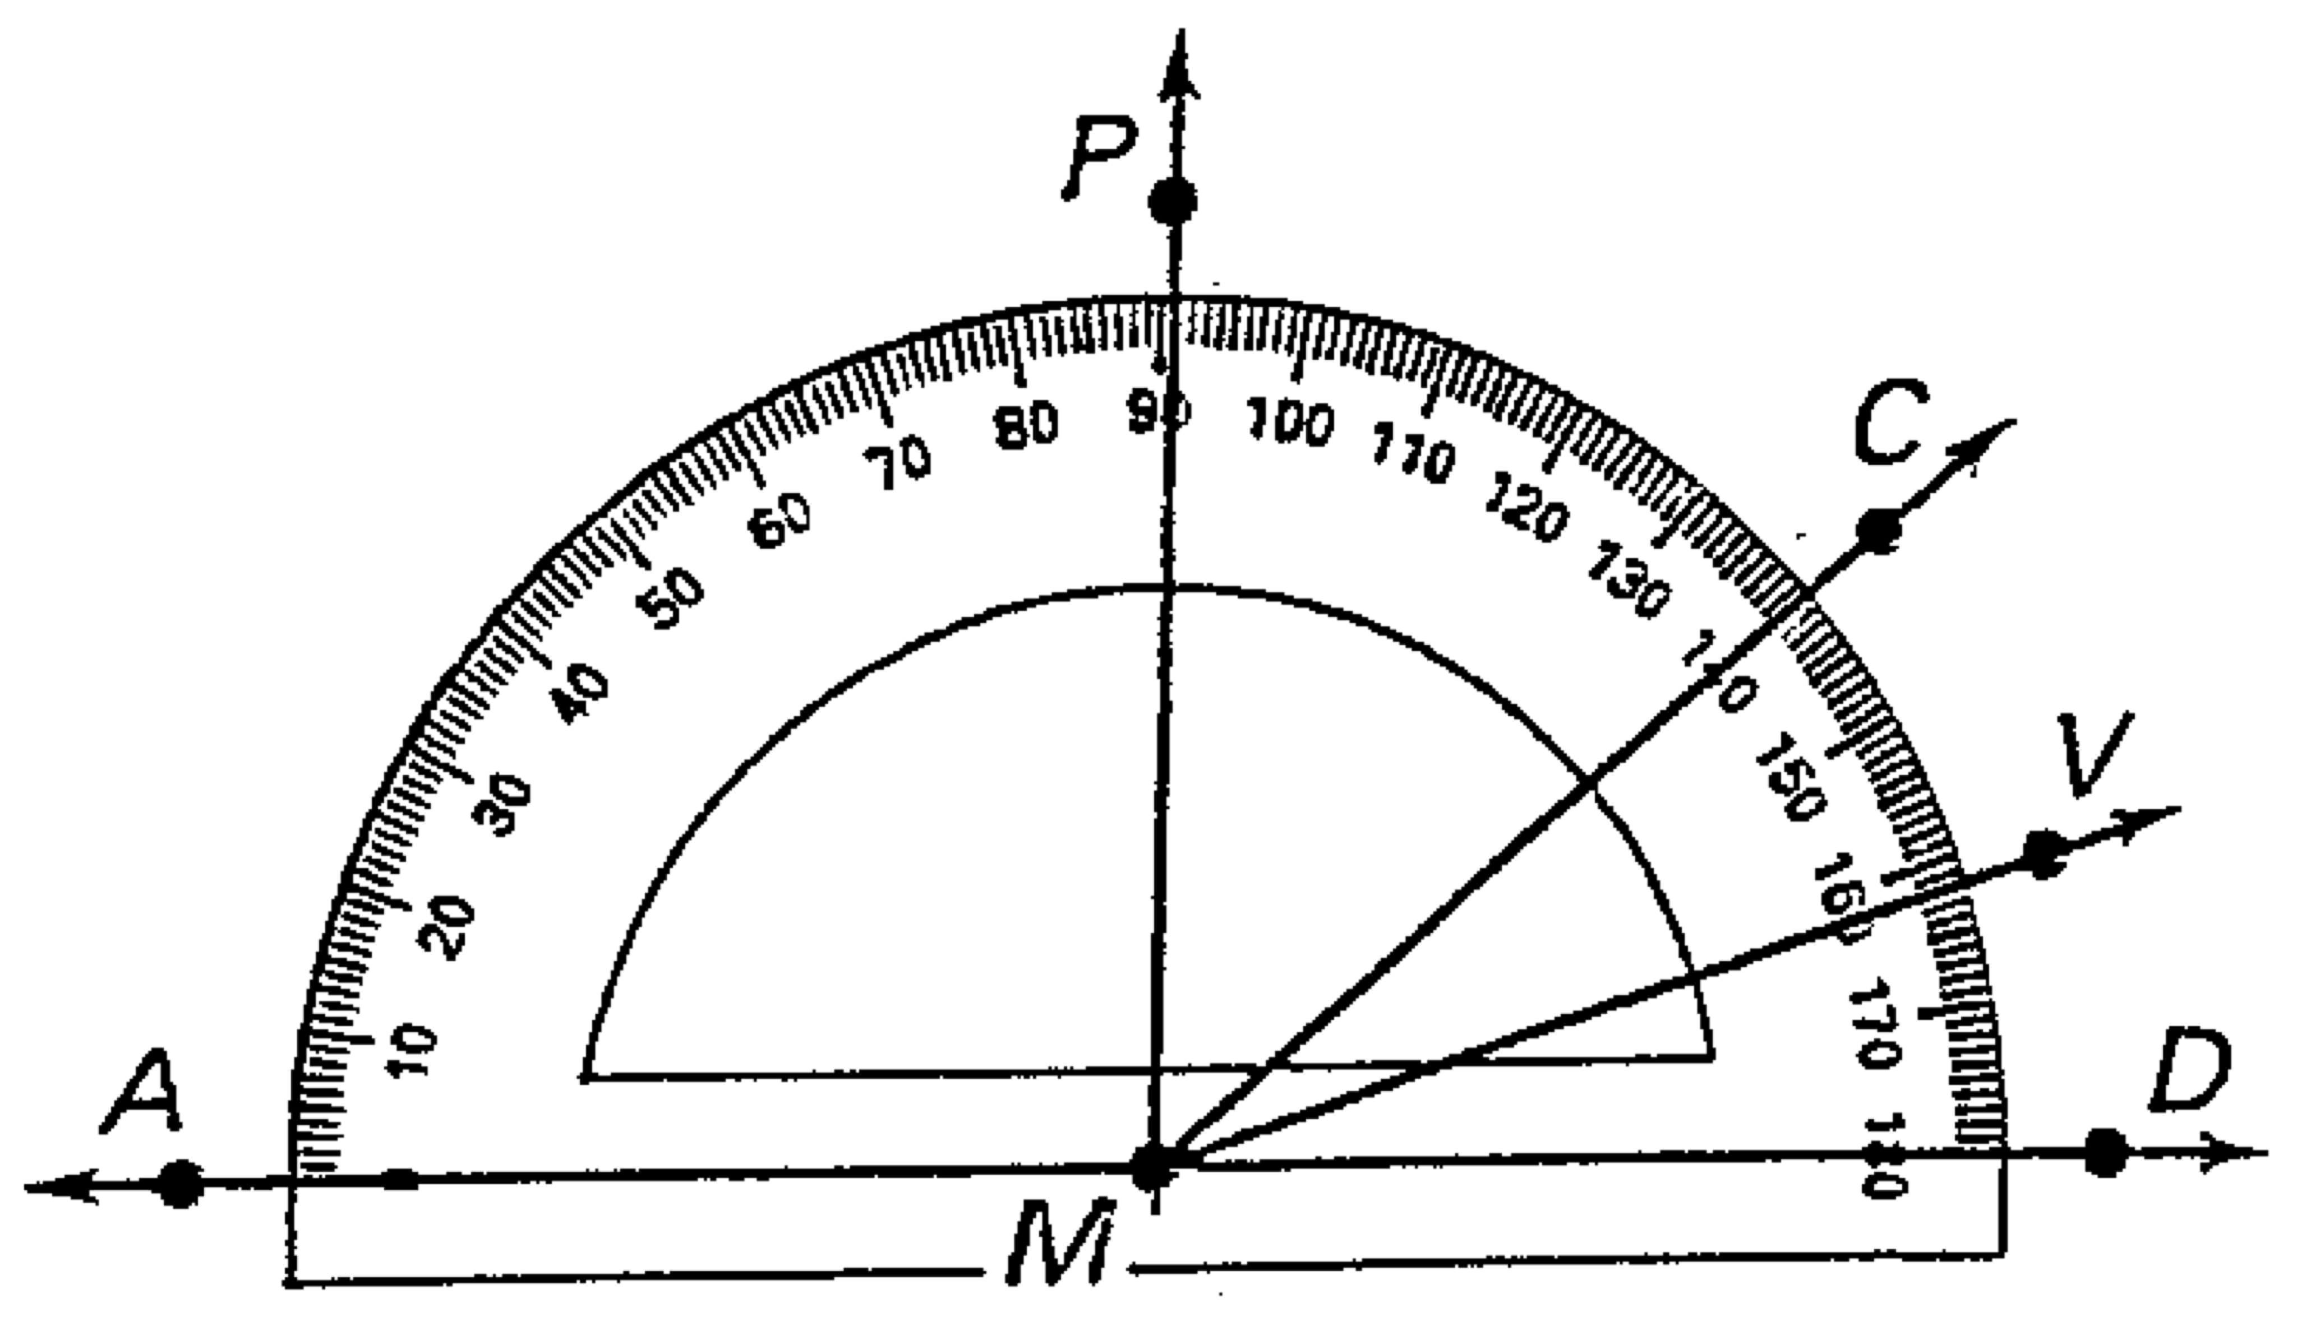**Use the diagram to find the measure of the angle.**

10. 

11. 

**In questions 12-14, refer to the diagram above. State what type of angle is formed.**

(Acute, right, obtuse, of straight)

12. 

13. 

14. 

15. Assume  and  are supplementary.

If 

16. Assume  and  are complementary.

If 

17. What is the length of the following line?

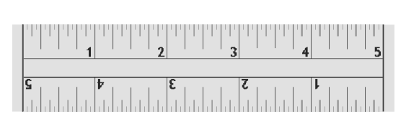

***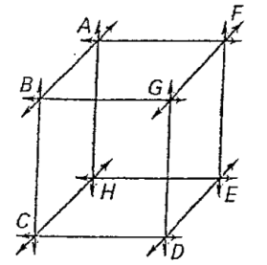*Use the figure below for #18-20. Complete each statement with *parallel, perpendicular, or skew****.* (3 points each)

**18. $\overset{⃡}{AH}$** and $\overset{⃡}{GF}$ are**_____________________________.**

**19. $\overset{⃡}{BC}$** and $\overset{⃡}{GD}$ are **_____________________________.**

**20. $\overset{⃡}{HE}$** andare **_____________________________.**

21. Jack is planning a summer camp, they want to put a fence around the camp. Which unit of measure would be appropriate?

a. miles b. feet c. centimeters d. inches