Transformations Lesson
Introduction: State the transformation & sketch the graph of the following functions.
1) $x^{2}$ 2) y = $x^{2}$ + 2 3) y = $x^{3}$ - 2 4) y = (x + 2$)^{3}$

5) y = (x - 2$)^{2}$ 6) y = (x - 1$)^{2}$ + 3 7) y = 2$x^{2}$ 8) y = $\frac{1}{2}x^{3}$

9) y = -$x^{2}$ 10) y = -(x + 3$)^{2}$ - 4

Review/solidify: complete the table and sketch the graph
f(x) = $\sqrt{x}$

x | f(x)
-4
-1
0
1
4
5

f(x) = $\sqrt[3]{x}$
x | f(x)
-8
-1
0
1
8
9

What are the y- intercepts and the x-intercepts of the functions?
What are the key points?
What is the domain of the function?
What is the range of the function?

Graph the following radical functions then check your solutions with a calculator:
1) f(x) = $\sqrt{x+1}$ 2) f(x) = $∛x$+3 3) f(x) = $\sqrt{x}$ – 4

4) f(x) = $\sqrt{x-2}$ + 1 5) f(x) = $-∛x$ 6) f(x) = $\sqrt{-x}$

Practice:
State the transformations of the following functions & sketch the graph. Label all intercepts. State the domain & range of the function. State the intervals on which the function is increasing or decreasing.
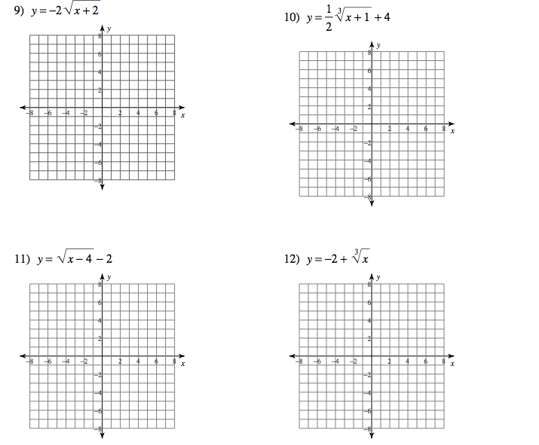

Extend:
Write an equation for the function given its graph.
1. 2.

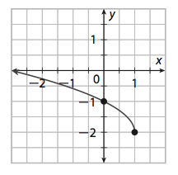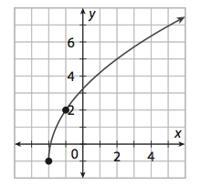

3.

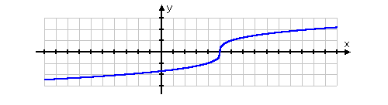

4.
