WS 2-5 H Name:____________________________________
Date:__________________ Class:______________

1. Name each angle in two different ways.
O
D
T
E
A
R
A) B) C)
C
N
T

2. Draw and label each angle.

A) ∠ TAN B) ∠ BIG C) ∠ SML D) ∠ DER

3. Classify the following angles as acute, right, obtuse or straight.

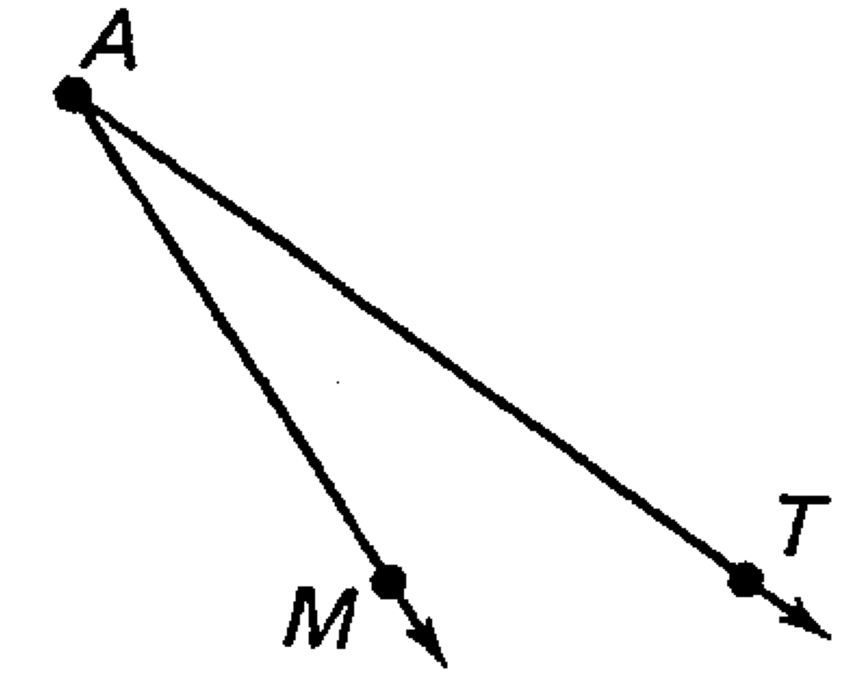
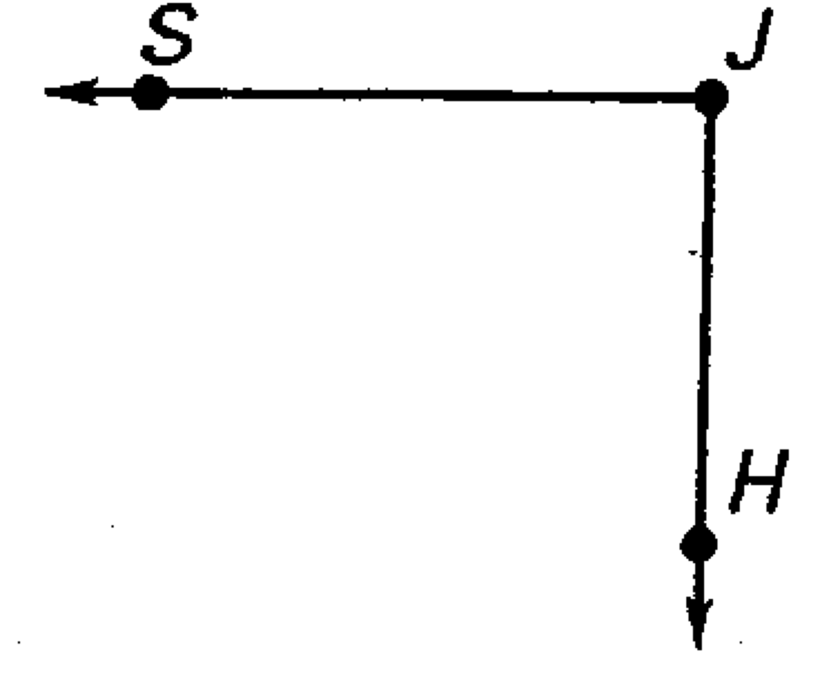
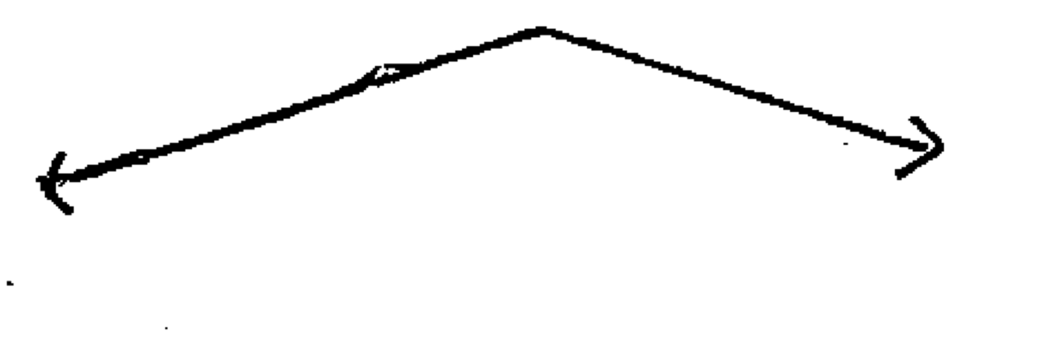
A) B) C)

4. Which of the following are true from the figure to be given?
Write true or false, if false correct the mistake.

- ∠ BDC is a straight angle.
P
A
E
F
D
B
C

- ∠ ADF is a right angle.

- ED is perpendicular to BC.

- ∠ BDA and ∠ CDF are complimentary.

- ∠ ADC is an obtuse angle.

- ∠ ADB is larger than ∠ FDC.

- ∠ BDA and ∠ ADE are complimentary.

