WS 4-2 Name:_________________________________
Date:_________________ Class:__________

Tell whether each of the following relations represent a function. Why or why not?
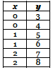
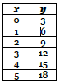
1. 2. 3.

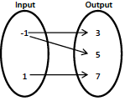
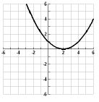
4. 5.

5. Write the following ordered pairs in function notation and a mapping
{ (2,4), (-3,1), (0,-2), (5,0) }

6. Write the following as a table and graph them
f(-3)= -2, f(-1)=0, f(1)=2, f(3)= 4

7. Provide an example of a relation that is a function

8. Provide an example of a relation that is not a function

